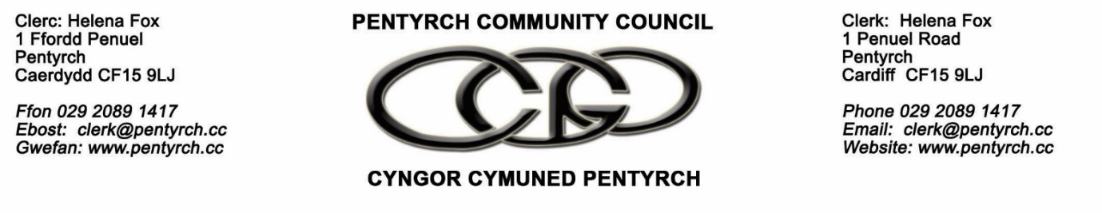
PLANNING COMMITTEE – 11am , 7th December 2022 via Microsoft Teams

MINUTES

- In attendance
Cllr’s K. Thomas , McGrath , Yarrow , Rosser ,
Clerk
Apologies
Cllr Jones

- To receive any declarations of interest
None

- Public and press session
In attendance - Gwaelod School Headteacher & Chair of Governors
Information was provided on the :
- Condition of the classrooms removed
- The 75 children without classrooms
- The Portakabin placed at the school in October
- The public meeting
- The changed location of the additional 2 portakabins , in response to residents comments
- Funding available for a permanent extension to the school
- School capacity
- Planning applications :

22/02633/FUL - Holiday Inn, Merthyr Road, Tongwynlais
No Comments
22/02775/DOC - Land to the South of Llantrisant Road
No Comments

22/02467/FUL - Community Centre Heol-y-bryn Pentyrch Cardiff CF15 9QL

It was agreed to recommend to Council that the application be supported given the surgery is an essential service to residents of Pentyrch .

22/02493/Ful – Retrospective application , Portakabin Gwaelod School

22/02722/Ful – Portakabin , Gwaelod School

It was agreed to recommend to Council that both the planning applications at the school be supported.

The need for certainty on the timescales to finalise a permanent extension at the school was discussed .
There is a need for certainty on the timescales to provide the permanent extension for the school. PCC therefore asks CCC to publish their proposals for the permanent extension including timescales as soon as possible.

The Committee also discussed other ways it could support the school in relation to the challenges it faces due to its location – car parking , traffic flows , children walking to school .

- Replacement LDP

It was noted that the next stage of the development of the LDP will be in early 2023 & PCC will need to consider this matter in due course.
- Date of the next meeting: 4th January 2023

