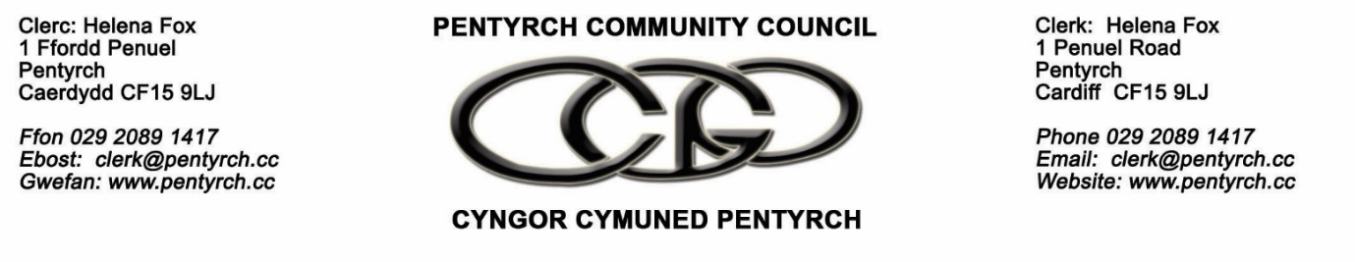
PLANNING COMMITTEE – 11am , 2cd November 2022 via Microsoft Teams

PCC welcomes attendance at its online meetings. The link to the Microsoft Teams meeting is on each Agenda.

- In attendance
- Cllr’s K Thomas , Rosser , Dixon , McGrath
- Apologies
- Cllr’s Yarrow , Sherwood , Jones
- To receive any declarations of interest
- None
- Public and press session
- None
- To consider and decide on responses to planning applications including, but not limited to:

- Application No 22/02157/DOC - Land North And South Of Llantrisant Road North West Cardiff ( deadline for comments -2cd Nov )
It was agreed to make No Comments
- Pre-application consultation for a proposed 9.9MW solar farm on land north of Ynysmaerdy - Deadline for comments , 7th November 2022

It was agreed to make No Comments

- Additional applications discussed :
22/02349 - 2 Ffordd yr Afon, Gwaelod y Garth: single story rear extension

21/02712 - Land at Mountain Rd, Pentyrch: discharge of conditions relating to materials

22/02271 - Plot 292 The Parish, Creigiau: rear conservatory

- Date of the next meeting: 7th December 2022

