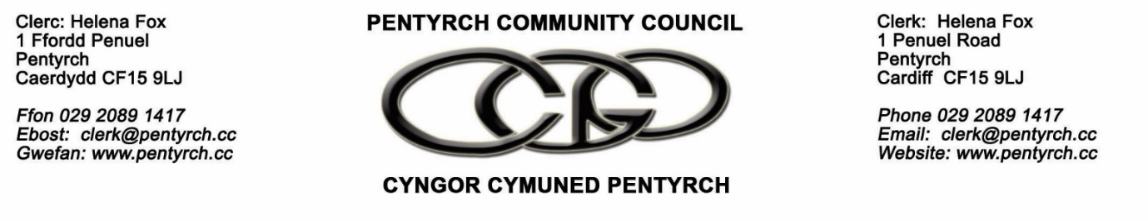
Minutes of the H&S Committee held at 2pm, June 23 2021 online
Present: Cllrs Mike Sherwood, Ian Jones, Sandie Rosser

In attendance : Helena Fox, Clerk

- To elect a Committee Chairman: Cllr Rosser proposed Cllr Jones, seconded by Cllr Sherwood. Cllr Jones accepted the nomination. It was RESOVLED that Cllr Jones be elected Chairman of the H&S Committee.
- To receive apologies for absence: Cllr K Thomas, J Quilter
- To receive any declarations of interest: There were none.
- To receive an update on any H&S incidents: There were none
- To receive an update on any H&S issues for PCC staff:
  - Covid issues: Office staff continue to work from home. CMOs work together or separately depending on Welsh Government guidance. This will remain in place until there are formal changes of policy from Welsh Government and practice at Cardiff Council.
- To receive an update on any inspections, audits and action plan:
  - Ellis Whittam visited PCC office on June 17 and met with the Clerk and CMOs. The report is awaited.
    - The Clerk attended online training for use of Ellis Whittam’s H&S Portal on June 15.
    - The Clerk will be provided with a list of policies and documents and training for PCC’s risk management procedures and these can be adapted as needed.
    - 1 Penuel Road should have an asbestos survey. It was RECOMMENDED to commission an asbestos report for 1 Penuel Road on the advice of Ellis Whittam.
  - Garth water run-off in Gwaelod y Garth. The Clerk has sought advice from Cardiff Council to commission a consultant report on the matter as agreed at PCC’s June 21 meeting.
    - Cllr Jones will be visiting the area to discuss the issue with residents. Cllr Rosser has also been contacted by residents.
  - Playground Memorial Park: Annual check was arranged for June 18 and the report is awaited.
  - Tree work due to be done before the end of summer 2021 has been commissioned.
    - The Clerk has asked if any timber suitable for making benches on site, such as in Terrace Woodlands, can be left.
  - Vehicles and tools have been serviced.
  - PATesting: The Clerk will arrange. It was not possible in 2020 due to Covid-19.
- To receive an update on any new H&S legislation or guidance: there was nothing new apart from Covid regulations. PCC is following Welsh Government and Cardiff guidelines. Ellis Whittam will keep PCC informed as part of its role as H&S advisors.
- To consider any financial implications:
  - Garth water run-off in Gwaelod. Once a report is received PCC will have an idea of what the financial implications could be.
  - The asbestos survey at Penuel Road will be a cost for PCC and there could be work that follows.
  - A large increase in the woodland ear-marked reserve was approved on Monday June 21.
  - In future budget years, it was RECOMMENDED that this committee could have its own budget to ensure all the basic H&S needs are covered and that the committee have delegated powers to spend within the budget.
- To consider H&S themes for future meetings:
  - Action plan from Ellis Whittam
  - Gwaelod surface water report
  - Asbestos report for Penuel Road
- To set a date for the next meeting: The next meeting will be held ten days after the Ellis Whittam is received.

Signed ____________________________________ Dated July 19 2021

