Minutes of the Finance Committee held at Noon, July 13 2020 held online via Microsoft Teams

This meeting is held under the following Welsh Statutory Instrument:

The Local Authorities (Coronavirus)(Meetings)(Wales) Regulations 2020

The requirement for the press and public to be present is temporarily suspended.

Present: Cllrs Mike Sherwood, Wynford Ellis Owen, Stuart Thomas, Karen Thomas

In attendance: Helena Fox

- To receive apologies for absence: Cllr John Harrison
- To receive any declarations of interest: there were none
- To receive the monthly bank reconciliations, statements and petty cash: Bank reconciliations and statements for accounts for June 2020 were presented and accepted. Signatures will be applied digitally.
- To receive the schedule of income and expenditure for June 2020: these was reviewed and accepted.
- To review investment of Council funds: There is £150,414.79 in the CCLA account and £33,628.01 in the Current account at the end of June. No transfer is needed to the Current account this month.
- To review expenditure/income against budget with explanation of variances and recommend any adjustments: The Clerk had prepared a detailed list of variances with recommendations for budget adjustments.
  - The Committee found this useful and made the following RECOMMENDATIONS for expenditure budget adjustments:

Item | Annual Budget Sum | Over or Under 15% Q1 Variance | Explanation of Variance between Actual Expenditure and end of Q1 Budget | Adjustments Recommended to Annual Budget Sum
Staff salary | 85,759 | Under | Budget sum is gross for tax and NI and pension. Budget includes £ for extra hours and staff not yet used. | Decrease to £70,500 to adjust to net salaries paid to existing staff and including estimates for extra staff/hours
Payroll | 72 | Over | Cost of Sage One increased by about £1/month after budget was set. | Increase to £84
PAYE, NI | 5,100 | Over | Budget sum shows employees and employers contributions combined. Budgeted sum is correct for Employer only | Increase to £13,655 to include Employer and Employee NI and tax for existing staff. Would be a small increase if extra staff hired but this is hard to estimate now
Pension | 15,123 | Over | Report shows employees and employers contributions combined. Budgeted sum is correct for Employer only | Increase to £20,340 to show Employer and Employee contributions for existing and extra staff
 |  |  |  | The overall effect of these adjustments is to lower the total salary, NI and pension costs by some £1,500
Creigiau Rec | 5,000 | Under | The £5000 is an EMR | No budget allocated for Rec expenditure. Use EMR and adjust EMR for next year's budget.

  - The Clerk confirmed that expenditure on new notice boards is shown in the budget at nominal code 4550.
- To review the Internal Audit Action Plan: The Clerk had prepared and circulated the Action Plan in advance. It was reviewed by the Committee. No comments were made.

- To revisit the Staff Review: This had been discussed in detail at the Staffing Committee held on July 8 with recommendations made to the July Full Council meeting. Funds remain in the budget for extra staff time.

- To consider amended Financial Regulations: Cllr Sherwood explained that the Regulations have been amended many times over the years and this latest draft was to clarify and simplify them. The Internal Auditor had submitted her comments on the draft.
  - Following a discussion it was RECOMMENDED that:
    - Cllr Sherwood amended the draft based on the Internal Auditor’s suggestions and the Committee’s comments. These will be reviewed at the next Finance Committee.
    - Once agreed by the Finance Committee, the draft will be sent to Once Voice Wales for their opinion. After that, it will go to full Council.

- To consider expenditure on survey pins for Creigiau Recreation Area: There is no budget for these pins which are unexpectedly needed to mark out the green boundaries of the land to be leased to Creigiau Recreation Charity (CRC).
  - It was RECOMMENDED that up to £500 be allocated from the Ear-Marked Reserve for Creigiau Recreation Area for the purchase of metal survey pins, the length to be agreed by the Clerk in discussion with the Community Maintenance Officers. PCC Members had met on-site with CRC members. The position of the boundary will need to be marked in advance and the position of the pins added to a drawing. It was noted that CRC’s future planned boundary path would cross in and out of the lease land. The pins will establish the boundary and protect trees for the future.

- To authorize for payment invoices and cheques presented by the RFO: Under the new Welsh Government Regulations and PCC’s own emergency delegated powers these are being authorised electronically.
- To consider any overtime for staff (excluding changes to permanent worked hours): none.
- To approve any proposed purchases for budgeted items up to £2,000: A subscription for Planning Aid Wales training at £120 will be spent out of the Members’ Training budget.
- To make recommendations on any budgeted expenditure over £2,000 as previously approved by Main Council:

Date of the next meeting: Wednesday August 12 2020 at 10:30am

Signed 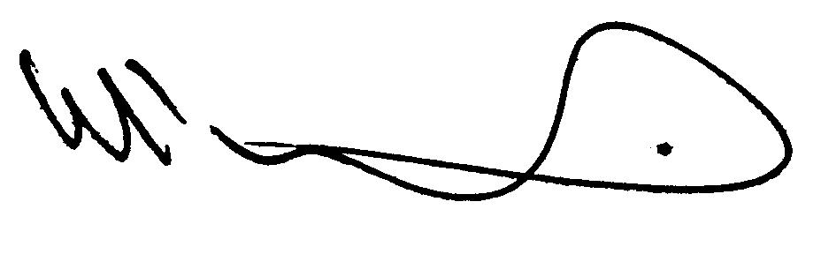 Dated July 20 2020

